**Protocol for Duplicate Trace Checker**

Given a series of section images, the program will find any objects with the same name and back-end coordinates. The user is given the option to delete these duplicate traces. While it is suggested to have Python on your computer, you can download the EXE file in step 2 and skip Python installation if desired.

1. If Python is not already installed on your computer, download the latest version for Windows at <https://www.python.org/downloads/>
   1. Run the EXE file that is downloaded. The installer screen should then pop up:

Please ensure that “Add Python [version] to PATH” is checked – it is not checked by default. After confirming this, click on “Install Now.”

* 1. Once the installation has finished, a message saying “Setup was successful” will be displayed. At this point, you can close the window. Python is now successfully installed on your computer.

1. Download the Python code from <https://github.com/julian-falco/DuplicateTraceChecker> by clicking on the green button that says “Code” and clicking “Download ZIP.” The program will be downloaded as a zipped folder.

1. Open the zipped folder and run the Python file (GuidedReconstructCropper.py)
   1. You can do this by double-clicking the file.
   2. Feel free to extract the contents of the zipped folder and/or run the program in IDLE.
2. Once the program starts running it will ask for the following:
   1. The name of the series
      1. The program assumes that the files will all be named after the series name and that the image files are TIF files (eg. ABCDE.SER, ABCDE.1, ABCDE.001.TIF)
   2. The number of sections in the series
      1. Include the 0 section; for example, if there are sections 0-200 in a series, then there are 201 sections.
   3. The file path for the folder containing the original series
      1. You will need to find the folder containing the Reconstruct files in your file explorer and copy the file path (circled in red below):

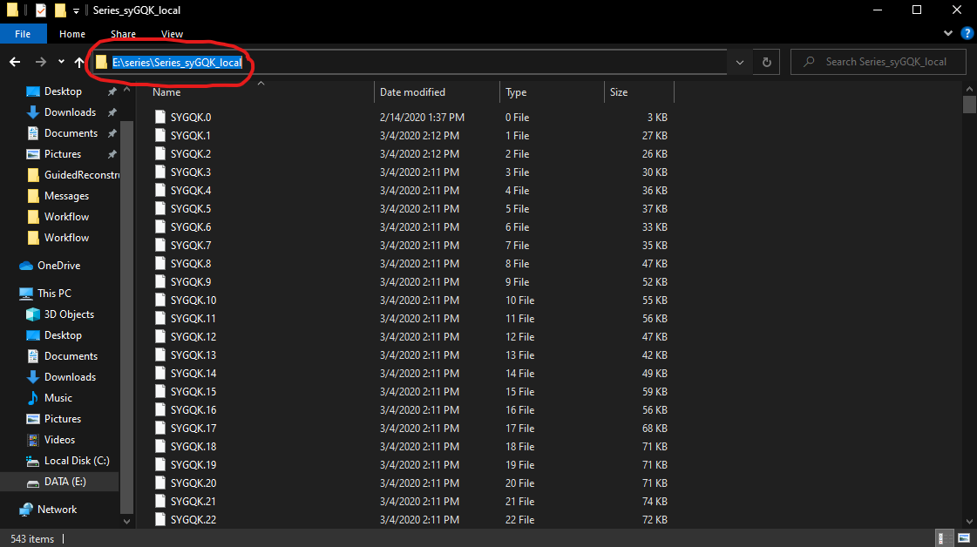

Paste this exact path into the program.

* 1. The file path for an empty folder that will contain the new Reconstruct files
     1. The program will create an entirely new set of section files, along with the original series file. Create an empty folder and repeat what you did in the previous step to copy its file path. Paste this path into the program.

1. At this point, the program should start running on its own. If the window displays an error, there may have been something that was entered in wrong – re-run the program and double-check that everything is entered correctly. The program will display the duplicate traces found – feel free to double-check these in RECONSTRUCT. You are given the option to delete these duplicates. After the program finishes, you will receive a message saying that it has run successfully.